**Project: E-Commerce Management System**

**OBJECT ORIENTED PROGRAMMING 2**

**Section: L**

**Group Name:  Hugs For My Bugs**

**Team Members:**

|  |  |  |
| --- | --- | --- |
| **Name** | **ID** | **Contribution** |
| **1.Samia Sharmin Dola** | **22-47126-1** | **Admin** |
| **2.Rifah Sanzida** | **22-47154-1** | **Seller, Start Page Form** |
| **3.Labib Hasan Bayzid** | **22-49292-3** | **Customer** |

**Supervised By: Jahid Hasan**

**Case Study**

In the ever-evolving landscape of e-commerce, our innovative E-commerce Management System emerges as a sophisticated solution crafted to streamline the complexity of online business operations. At its core, a well design structured framework governs the interactions among diverse entities, orchestrating a seamless interplay within the system.   
Foremost in the hierarchy is the ADMIN, the omnipotent overseer of the system. The ADMIN is the key to the system's operation, with a special combination of authority and responsibility. Equipped with crucial data to obtain access into a domain where choices form the whole e-commerce terrain.   
Central to the ecosystem is the SELLER, they play an essential role and are endowed with the ability to browse and engage in the digital marketplace. SELLER registration mandates the provision of essential details, securing their position within the system. Under the vigilant supervision of the ADMIN, SELLERS are essential in ensuring that the product catalog that potential customers might explore is diverse.   
CUSTOMERS, considered the lifeblood of every e-commerce venture, embark upon their journey through a streamlined registration process. This stage requires the submission of relevant details, thereby providing access to the comprehensive suite of services and products available within the system.  CUSTOMERS gain entry into a domain of limitless possibilities. Their interaction with the system involves navigating a virtual marketplace, perusing and selectively adding PRODUCTS to their CART.   
Within the CART, a combination of selected PRODUCTS materializes, each transaction imbued with a unique identity, encompassing a distinctive cart ID, total cost, product ID, and quantity. Transitioning seamlessly from CART to ORDER, CUSTOMERS confirm their selection, building a structured ORDER representation, featuring an order ID, product ID, total cost, and transaction date.   
The pinnacle of the e-commerce transactional process resides in the PAYMENT stage. CUSTOMERS are presented with a selection of payment types, namely cash, Nagad, and Bkash, each offering distinct advantages. The payment process involves a comprehensive breakdown of the financial transaction, encompassing options for discounts and the final price.   
 In our E-commerce Management System, we act as the organizer, making sure that ADMIN, SELLER, CUSTOMER, PRODUCT, CART, ORDER, and PAYMENT all work together smoothly. We focus on creating a system that is easy for users and promises to improve the way admin, sellers, and customers interact in the world of online shopping. Our goal is to make the e-commerce experience better for everyone involved. 

**ER Diagram**

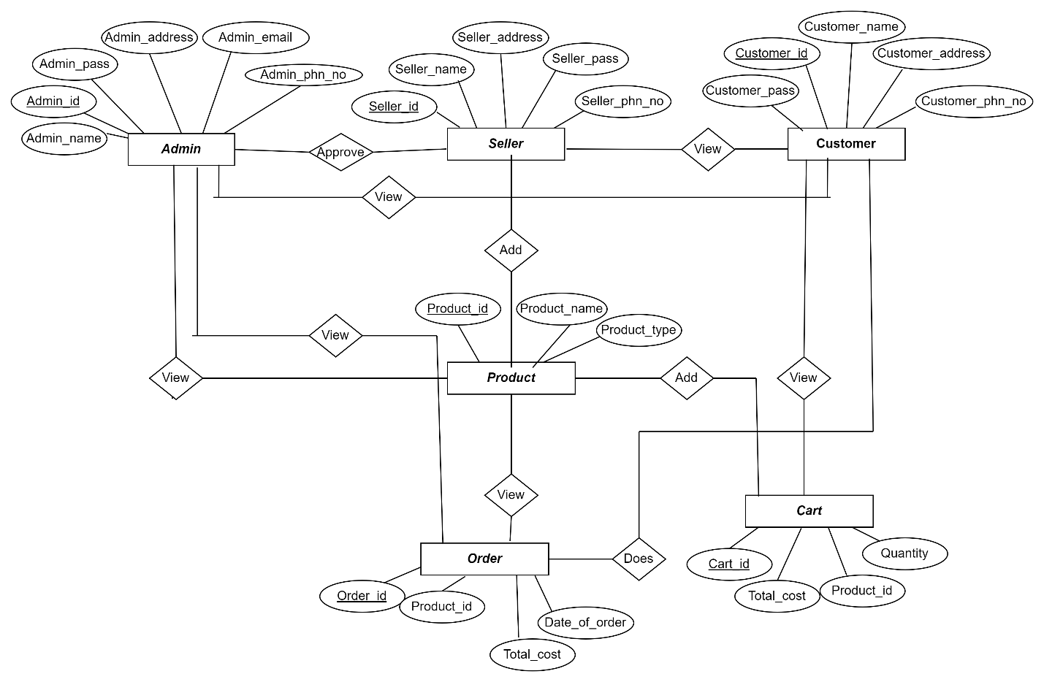

**Schema Diagram**

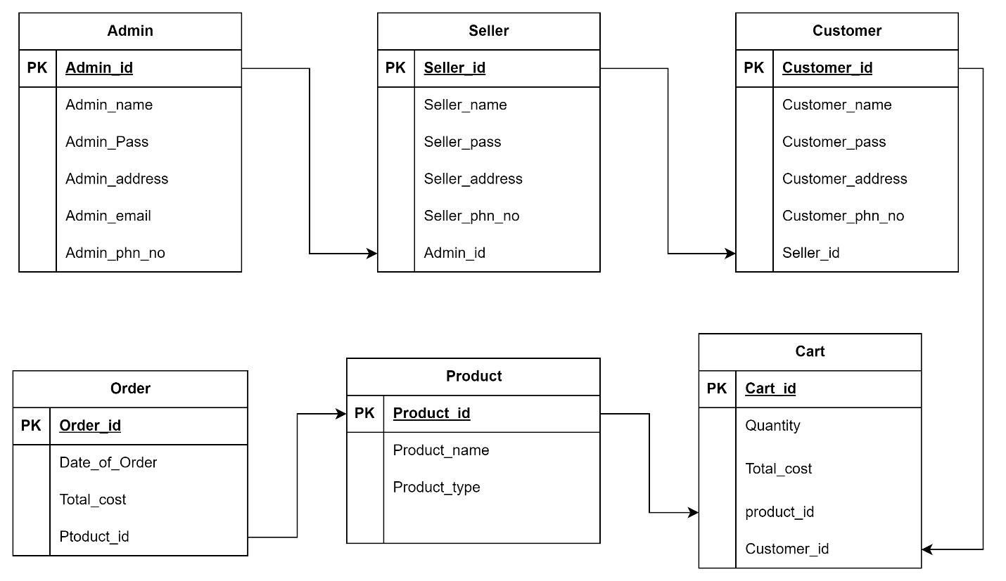

**Start Page Form**

**Admin Windows Form**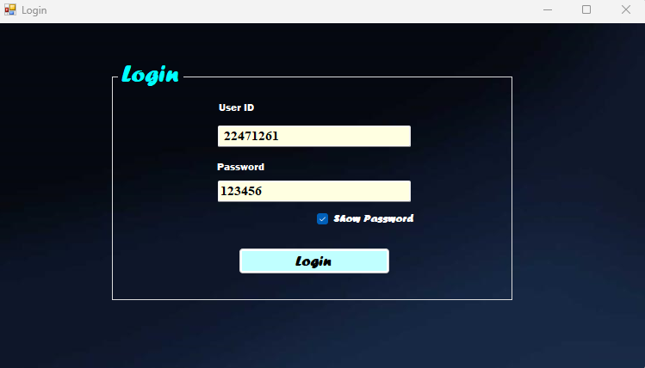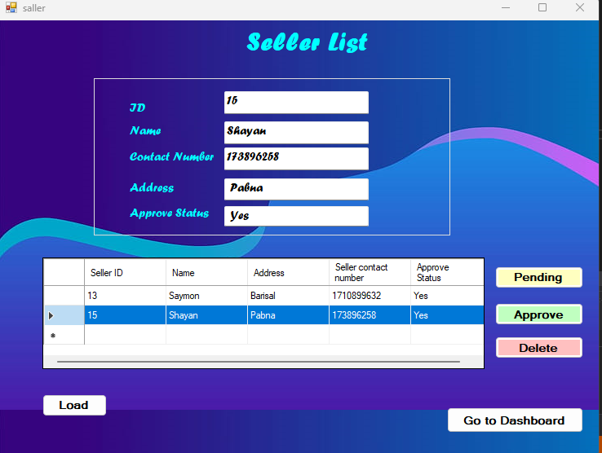

**Admin Managarel View Form**

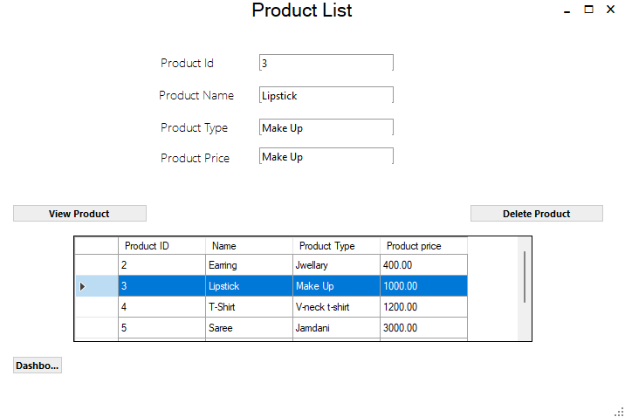

**Admin Windows Form**

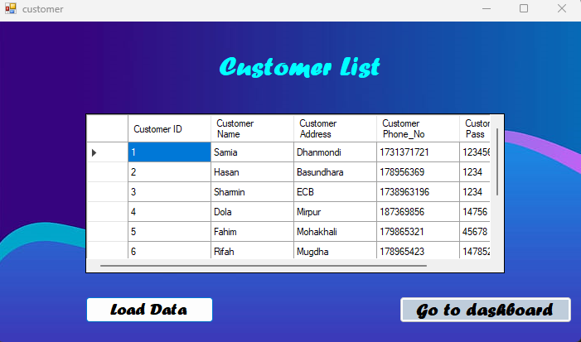

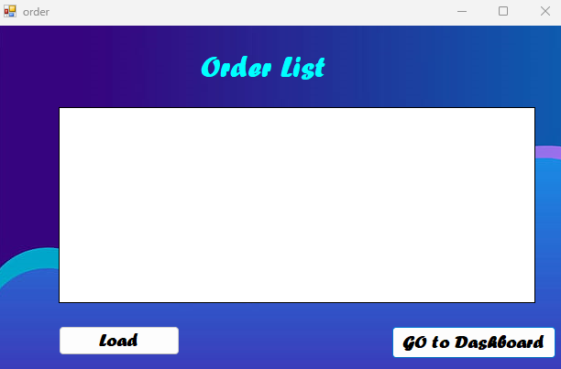

**Seller Windows Form**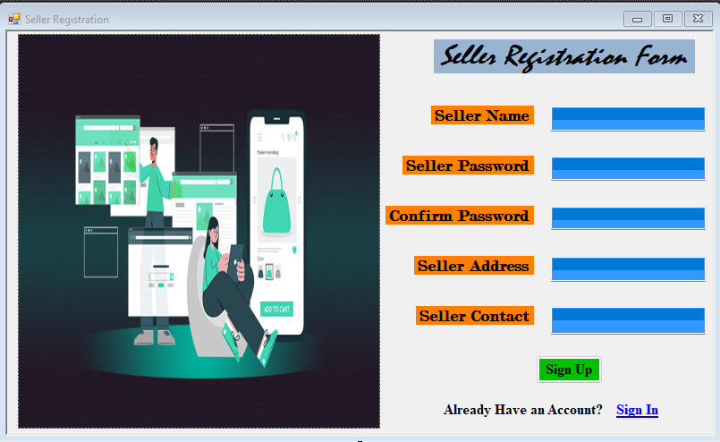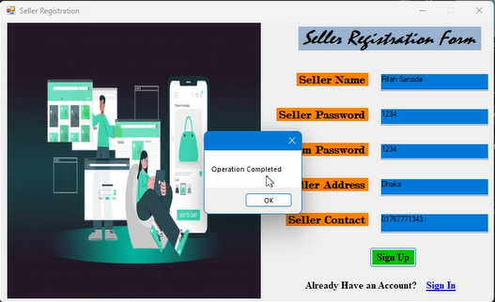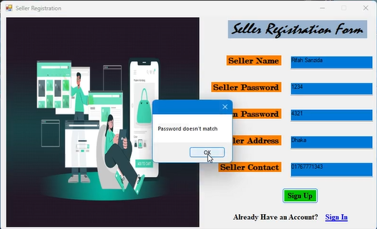

**Seller Windows Form**

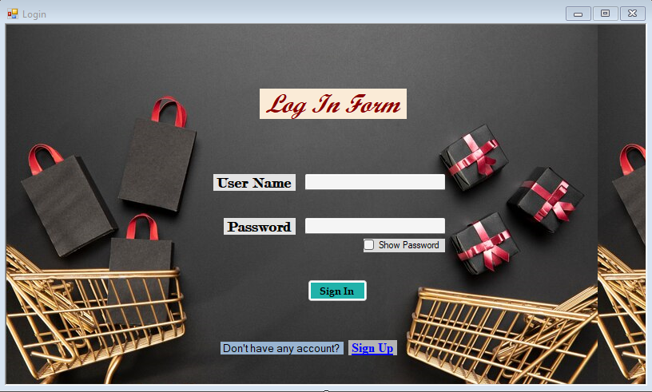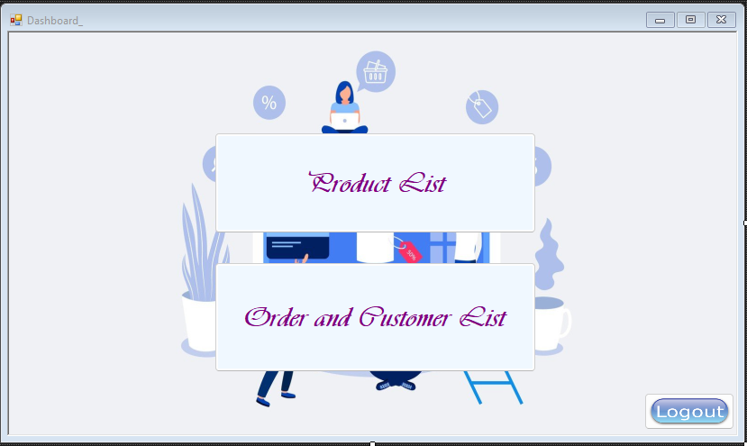

**Seller Manageral view Form**

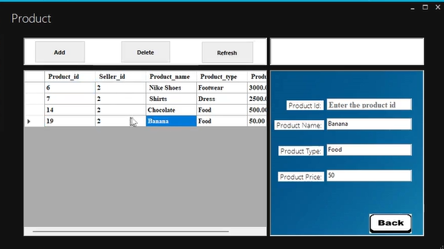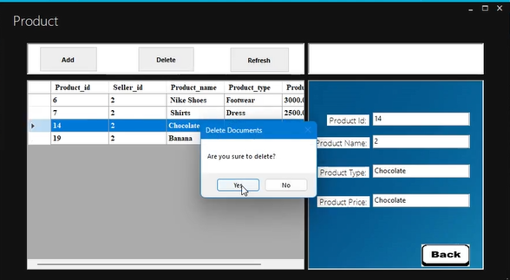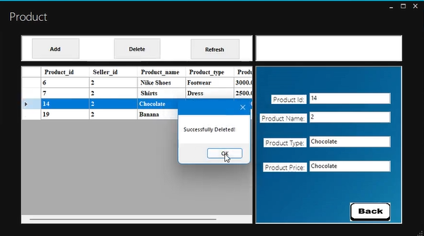

**Seller Windows Form** 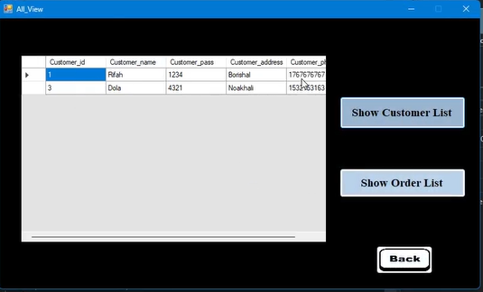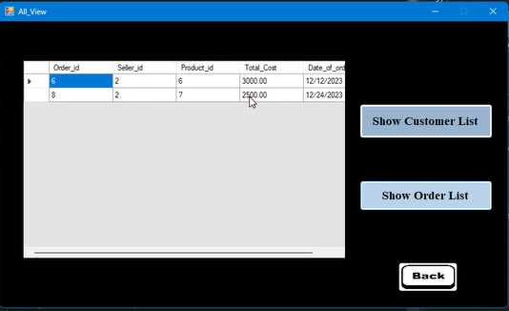

**

**Customer Managarel View Form**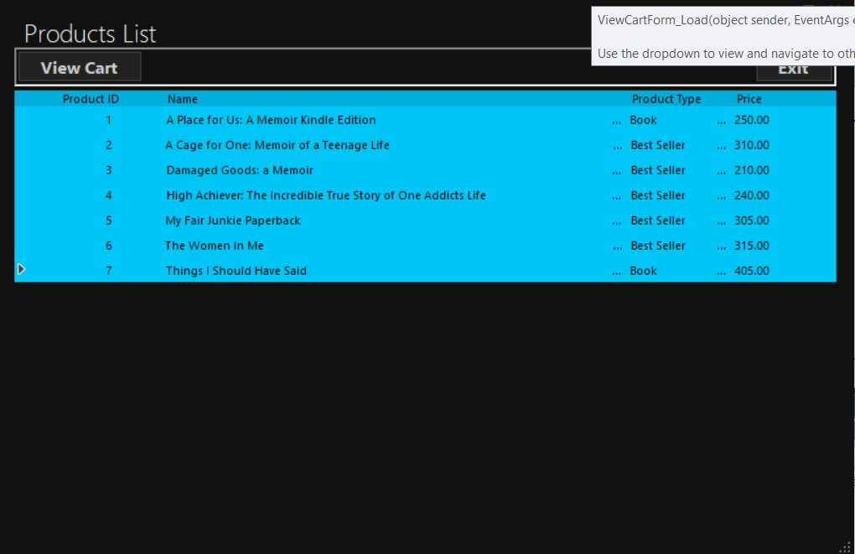

**Customer Windows Form**